**AGU COMPUTER ENGINEERING**

**CAPSTONE PROJECT**

**FINAL REPORT**

**by**

**Student Name**

**Ahmet Eren CEYLAN**

**Resul Özkale**

**Student ID Number**

**2011051053**

**Date of the Submission**

**SUMMARY**

This project is centered on the classification of soil into four categories (A, B, C, and D) using computer vision techniques, with soil and clay ingredient percentages serving as the primary criteria. The project originated as an effort to determine soil texture, which is a critical factor in agricultural planning, irrigation management, and soil health assessment. Soil texture, defined by the relative proportions of sand, silt, and clay particles, influences water retention, nutrient availability, and root penetration, thereby impacting crop yield and land use decisions.

Initially, our goal was to identify soil texture precisely. However, during the process of labeling soil samples based on their silt ratios, we faced challenges in accurately measuring these ratios using standard sieves. Silt particles, which are finer than sand but coarser than clay, require meticulous separation methods that were not feasible with the available tools. To address this, we adopted a method where soil samples were passed through sieves to categorize particles into their respective size ranges. Following this, we created distinct soil mixtures for each class, ensuring consistency in the classification criteria.

To facilitate the classification process, we collected 100 soil sample images from the dormitory garden. These images were evenly distributed across the four classes, with 25 images per class. Recognizing the limitations of this dataset size, we applied various data augmentation techniques, including rotation, flipping, and scaling, to expand the dataset to 300 images. The augmented dataset was then split into training (204 images), validation (48 images), and test (48 images) sets to train and evaluate multiple machine learning and deep learning models.

Despite these efforts, the models, including CNN, EfficientNet, MobileNet, ResNet50, Random Forest, and VGG19, yielded unsatisfactory results when trained on the 300-image dataset. This prompted the collection of an additional 100 images, bringing the dataset size back to 300 images after augmentation. Subsequently, we combined the two datasets to create a final dataset of 600 images. This comprehensive dataset allowed us to re-evaluate model performance, leading to improved classification accuracy. By integrating traditional and advanced techniques, this project not only addresses the challenges of soil classification but also contributes to the broader application of computer vision in agricultural and environmental domains.

1. **INTRODUCTION**

Soil texture plays a fundamental role in agricultural productivity, environmental sustainability, and civil engineering practices. Its texture and composition—defined by the relative proportions of sand, silt, and clay—are crucial in determining its suitability for various applications. Soil texture affects water retention, nutrient availability, and structural stability, thereby influencing crop growth, irrigation strategies, and construction practices. Given its importance, accurately determining soil composition has been a key focus in fields such as agriculture, environmental science, and engineering. Traditional methods, however, are often time-consuming, labor-intensive, and reliant on specialized laboratory equipment, posing challenges for rapid and precise soil analysis.

This project draws inspiration from soil texture classification methods but focuses specifically on identifying the total clay and silt content in soil samples to classify them into one of four predefined categories: A, B, C, or D. Unlike comprehensive soil texture analysis, which measures the proportions of sand, silt, and clay, our approach emphasizes practical simplicity by targeting the combined clay and silt ratios. The classification criteria for these categories are based on the proportion of clay and silt in the soil sample: if the combined clay and silt content in a sample fall between 0% and 25%, the soil is classified as Class A. For samples with a clay and silt content between 25% and 50%, the soil belongs to Class B. Similarly, samples with 50% to 75% clay and silt content are categorized as Class C, while those with 75% to 100% clay and silt content are classified as Class D.

This straightforward classification system allows for a clear and consistent determination of soil type based on the relative abundance of finer particles (clay and silt). By grouping samples into these four categories, we aim to provide a practical and scalable approach to soil classification that maintains relevance to applications in agriculture, environmental planning, and related fields. This methodology not only simplifies the classification process but also ensures that the criteria are robust and applicable to diverse soil samples, facilitating the development of a reliable dataset for machine learning-based classification.

The project began with the collection of soil sample from AGU dorm garden. This sample was processed in a civil engineering laboratory to separate their components into two primary categories: total soil and clay-silt mixture. Due to the limitations of the sieves available, we were unable to isolate clay and silt particles separately. Instead, the combined clay-silt fraction was treated as a single entity for classification purposes. The soil samples were passed through a series of sieves to separate particles by size, ensuring that the proportions of larger soil particles and the finer clay-silt mixture were accurately determined. Each of these separated components was carefully stored in labeled bags for subsequent dataset preparation.

One of the key challenges encountered during the project was the labor-intensive process of soil collection and processing. Gathering samples from diverse locations required meticulous planning to ensure representation across different soil types. Once collected, the samples underwent sieving and separation in the laboratory, a process that was both time-consuming and physically demanding. The manual effort required to prepare the dataset, including the proportional recombination of soil, clay, and silt components to simulate real-world mixtures, highlighted the need for innovative and automated solutions in soil analysis.

The dataset for this project was meticulously constructed by combining the separated soil, clay, and silt components in predefined ratios corresponding to the four categories. This approach ensured consistency and precision in the classification criteria. A total of 100 initial soil sample images were captured to form the basis of the dataset. These images were then augmented through techniques such as rotation, flipping, and scaling to expand the dataset size to 300 images. Despite these efforts, the models trained on this initial dataset—spanning CNN, EfficientNet, MobileNet, ResNet50, Random Forest, and VGG19—did not achieve satisfactory classification accuracy.

To address this limitation, additional soil samples were collected, and a second dataset of 100 images was created. After applying the same augmentation techniques, we achieved 300 picture again and tried with different models. Finally, we merged these 2 datasets and reached 600 images, allowing for more robust model training and evaluation. This iterative approach allowed us to overcome the initial dataset limitations and achieve improved performance in soil classification.

This project aims to address these challenges by leveraging computer vision and machine learning techniques to develop a model capable of classifying soil texture based on image data. Using soil samples collected and processed into distinct texture classes, we trained and tested various models, including CNNs and other advanced architectures, to achieve accurate classification. The project further incorporates data augmentation to overcome dataset limitations, thereby enhancing model robustness.

Our contributions include:

1. Developing a standardized dataset of soil images representing distinct texture classes.
2. Applying advanced machine learning techniques for soil classification.
3. Proposing a cost-effective and efficient alternative to traditional soil texture determination methods.

Through these efforts, this project not only advances the field of soil classification but also provides a framework for applying AI-driven solutions to broader agricultural and environmental challenges.

1. **RELATED WORK (4 pages at most)**

Soil texture classification is a critical task for numerous agricultural and environmental applications, and recent studies have explored a variety of techniques for automating this process, particularly through the use of machine learning and computer vision. These efforts have focused on improving the efficiency and accuracy of soil texture analysis, with varying degrees of success.

In a study by Pedro Augusto de Oliveira Moraisa et al. (2019), the authors proposed a method to predict soil texture based on image analysis techniques. Their approach focused on classifying soil into distinct texture categories, leveraging visual features extracted from soil images. The study utilized traditional image processing techniques in combination with machine learning algorithms to classify soil texture accurately. However, the approach required extensive preprocessing of soil images and was constrained by the need for high-quality image acquisition and labeling.

Swetha et al. (2020) further advanced the idea of soil texture prediction by using smartphone-captured images, making the process more accessible for field applications. Their study incorporated deep learning models, particularly convolutional neural networks (CNNs), to classify soil textures directly from images captured with smartphones. This approach was promising in terms of accessibility and ease of use but faced challenges in terms of accuracy, particularly for diverse soil types and varying image quality in real-world settings. Their work emphasized the potential of mobile devices in soil classification but also highlighted the limitations imposed by dataset size and model generalization.

The study by Shinya Inazumi et al. (2020) explored the use of an artificial intelligence (AI) system for supporting soil classification. Their work integrated various AI models, including deep learning and decision tree-based classifiers, to develop a robust system for soil analysis. They focused on creating a flexible system capable of processing a range of soil samples for classification. While their method showed promise in automating soil classification, it relied heavily on manual data labelling and preprocessing, and the results were often limited by the diversity of soil samples included in the dataset.

While these studies provide valuable insights into soil classification, the methods employed often suffer from limitations, such as the need for high-quality images, specialized equipment, or manual intervention in data labelling. Additionally, the use of small or unbalanced datasets has hindered the generalizability of the models. In contrast, our approach aims to address these limitations by using a simple, yet effective classification system based on combined clay and silt content, focusing on practical and scalable solutions for soil analysis. By leveraging computer vision techniques and an augmented dataset, we seek to enhance classification accuracy and overcome challenges related to dataset size and diversity. Furthermore, our dataset augmentation strategy—using rotation, flipping, and scaling—ensures that the models trained on our dataset are more robust and capable of handling real-world soil variability.

Our work distinguishes itself by emphasizing a clear, practical classification system based on the relative abundance of clay and silt in soil, which simplifies the process of classification and enhances its scalability. Unlike previous works that aimed to classify a broader range of soil textures, we focus on a targeted classification approach that ensures better consistency and robustness in training machine learning models. Furthermore, our dataset augmentation techniques and the inclusion of diverse soil samples through iterative data collection enable the model to generalize better and handle real-world variations in soil composition. Through these innovations, our approach aims to provide a cost-effective, efficient solution to soil classification that is suitable for a wide range of agricultural and environmental applications.

1. **SYSTEM MODEL**

The system model for this soil classification project leverages computer vision and machine learning techniques to classify soil texture based on the proportions of clay and silt in soil samples. The model architecture is designed to handle the challenges of limited dataset size, variable image quality, and the need for real-world applicability in agricultural and environmental contexts. It integrates various stages, including data preprocessing, dataset augmentation, model training, and evaluation, to ensure robust and accurate soil classification.

**3.1 Dataset Collection and Preprocessing**

The first step in the system model is the collection of soil sample images. These samples were gathered from the AGU dormitory garden and processed in a civil engineering laboratory to separate soil components into their respective categories: total soil and clay-silt mixtures. Due to limitations in available sieves, the clay and silt particles were combined as a single entity for classification. A total of 100 soil sample images were captured, initially forming the base dataset.

After the initial image collection, preprocessing steps were applied to prepare the dataset for model training. The preprocessing involved the following key tasks:

1. **Image resizing**: All images were resized to a consistent dimension to ensure uniformity in the input data for the machine learning models.
2. **Normalization**: The pixel values of the images were normalized to ensure that the range of input data for the models was consistent, facilitating better learning.
3. **Labeling**: Each image was labeled according to its respective soil class (A, B, C, or D), based on the combined clay and silt content as described in the introduction.

**3.2 Dataset Augmentation**

To mitigate the limitations imposed by the relatively small initial dataset (100 images), data augmentation techniques were employed. The goal of data augmentation was to artificially increase the dataset size and introduce variability in the training data, thereby improving model robustness and preventing overfitting. The following augmentation techniques were applied:

* **Rotation**: Images were rotated by various angles to simulate different perspectives and conditions under which soil images might be captured in real-world scenarios.
* **Flipping**: Horizontal and vertical flipping were applied to diversify the dataset, helping the model learn invariant features.
* **Scaling**: Images were scaled by random factors to ensure that the model would learn to classify soil texture irrespective of object sizes in the images.
* **Translation**: The images were shifted horizontally and vertically to simulate slight misalignments that could occur during real-world data collection.

These augmentations expanded the dataset to 300 images, after which the dataset was split into training (204 images), validation (48 images), and test (48 images) sets. This dataset was further augmented by collecting additional 100 images and merging them with the existing dataset, bringing the total number of images to 600. This final dataset served as the foundation for model training and evaluation.  
  
**3.3 Model Selection and Training**

Several machine learning and deep learning models are employed for soil classification. These include:

* **Convolutional Neural Networks (CNNs):** Traditional CNNs are used for image classification tasks due to their ability to capture spatial hierarchies in the data.
* **EfficientNet:** A more advanced architecture that improves model accuracy by balancing network depth, width, and resolution.
* **MobileNet:** A lightweight architecture ideal for mobile and edge computing applications, ensuring that the model can be deployed in resource-constrained environments.
* **ResNet50:** A deeper model that incorporates residual connections, which help the network learn complex features more efficiently.
* **VGG19:** Another deep architecture that helps with feature extraction and classification by using very deep layers.
* **Random Forest:** A traditional machine learning model that is capable of classifying based on aggregated decision trees, useful for structured data.

The models are trained on the augmented dataset, and their performance is evaluated using accuracy, precision, recall, and F1-score metrics. Cross-validation is performed to ensure the models’ robustness.

**3.4 Model Evaluation and Fine-tuning**

During model evaluation, various performance metrics are calculated. These metrics are used to identify which model is most effective at classifying the soil sample images. Additionally, hyperparameter tuning is carried out to optimize each model’s performance. For CNNs and other deep learning architectures, this involves adjusting the learning rate, batch size, number of epochs, and other parameters.

Fine-tuning involves adjusting pre-trained models like EfficientNet, MobileNet, and ResNet50 to the specific characteristics of the soil dataset. Transfer learning, where weights from pre-trained models are fine-tuned on the current dataset, is used to speed up the training process and improve model accuracy, especially with the limited dataset.

1. **PROPOSED SOLUTION APPROACHES (10 pages at most)**

**4.1 Implementation of Project**

In our project, the implementation of the soil classification system begins with the preparation and analysis of soil samples in the laboratory. Below are the steps and considerations for this phase:

**4.1.1 Soil Sample Collection**

Soil samples must first be collected from AGU dorm garden of interest to ensure diversity in the dataset. The samples are then transported to the laboratory in containers designed to preserve their original state. It is important to mark each sample with identification codes for traceability. A standardized methodology for sample collection is applied to avoid bias and contamination.

**4.1.2 Sample Preparation**

Upon arrival in the laboratory, soil samples undergo preparation to make them ready for imaging and classification. The preparation steps involve:

Drying: Soil samples are dried in an oven at a controlled temperature (usually around 40-50°C) for 24-48 hours to remove excess moisture. This step ensures uniformity in the soil texture for imaging.

Sieving: After drying, soil particles are sieved through a mesh to separate them into distinct size fractions, ensuring uniformity in particle size for better feature extraction during image analysis. Grinding: If the samples contain larger clumps or organic material, they are ground into finer particles. This reduces sample heterogeneity and makes the analysis more consistent. Here are 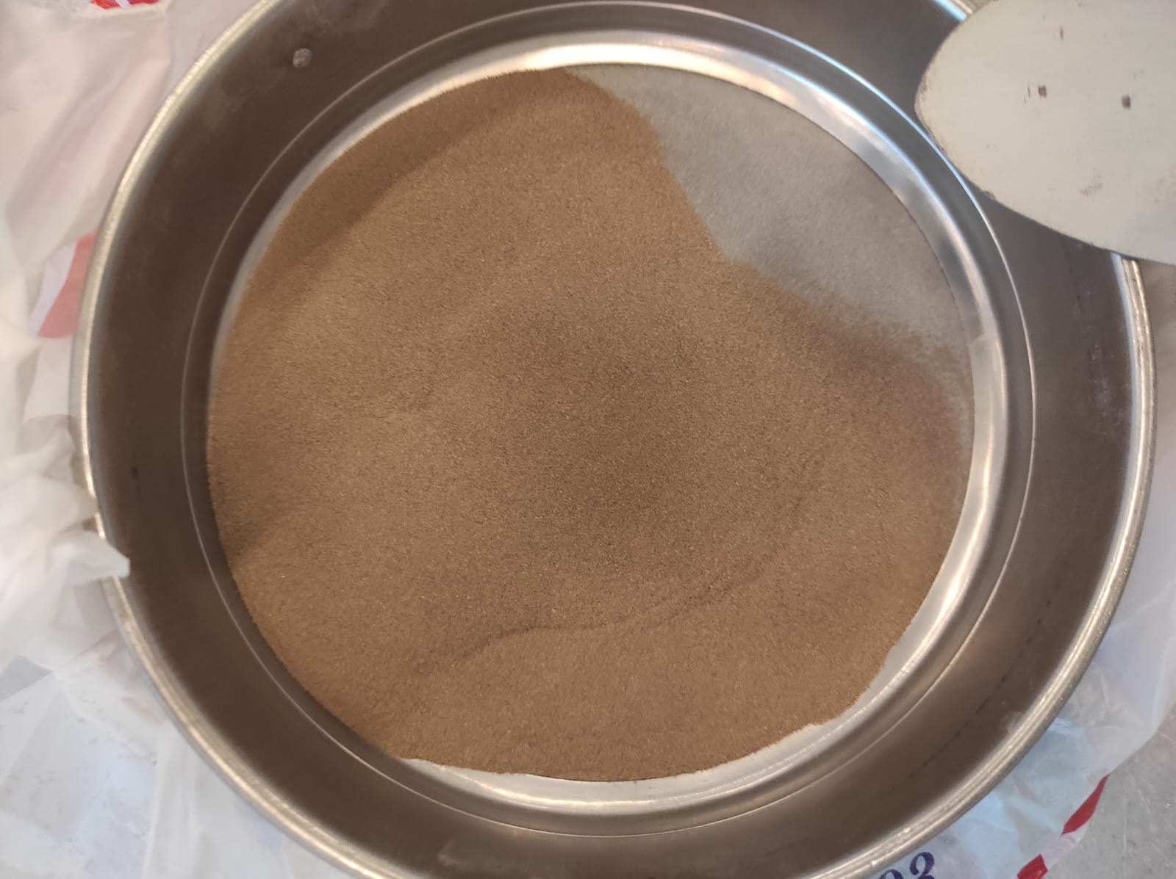some pictures taken in the laboratory.

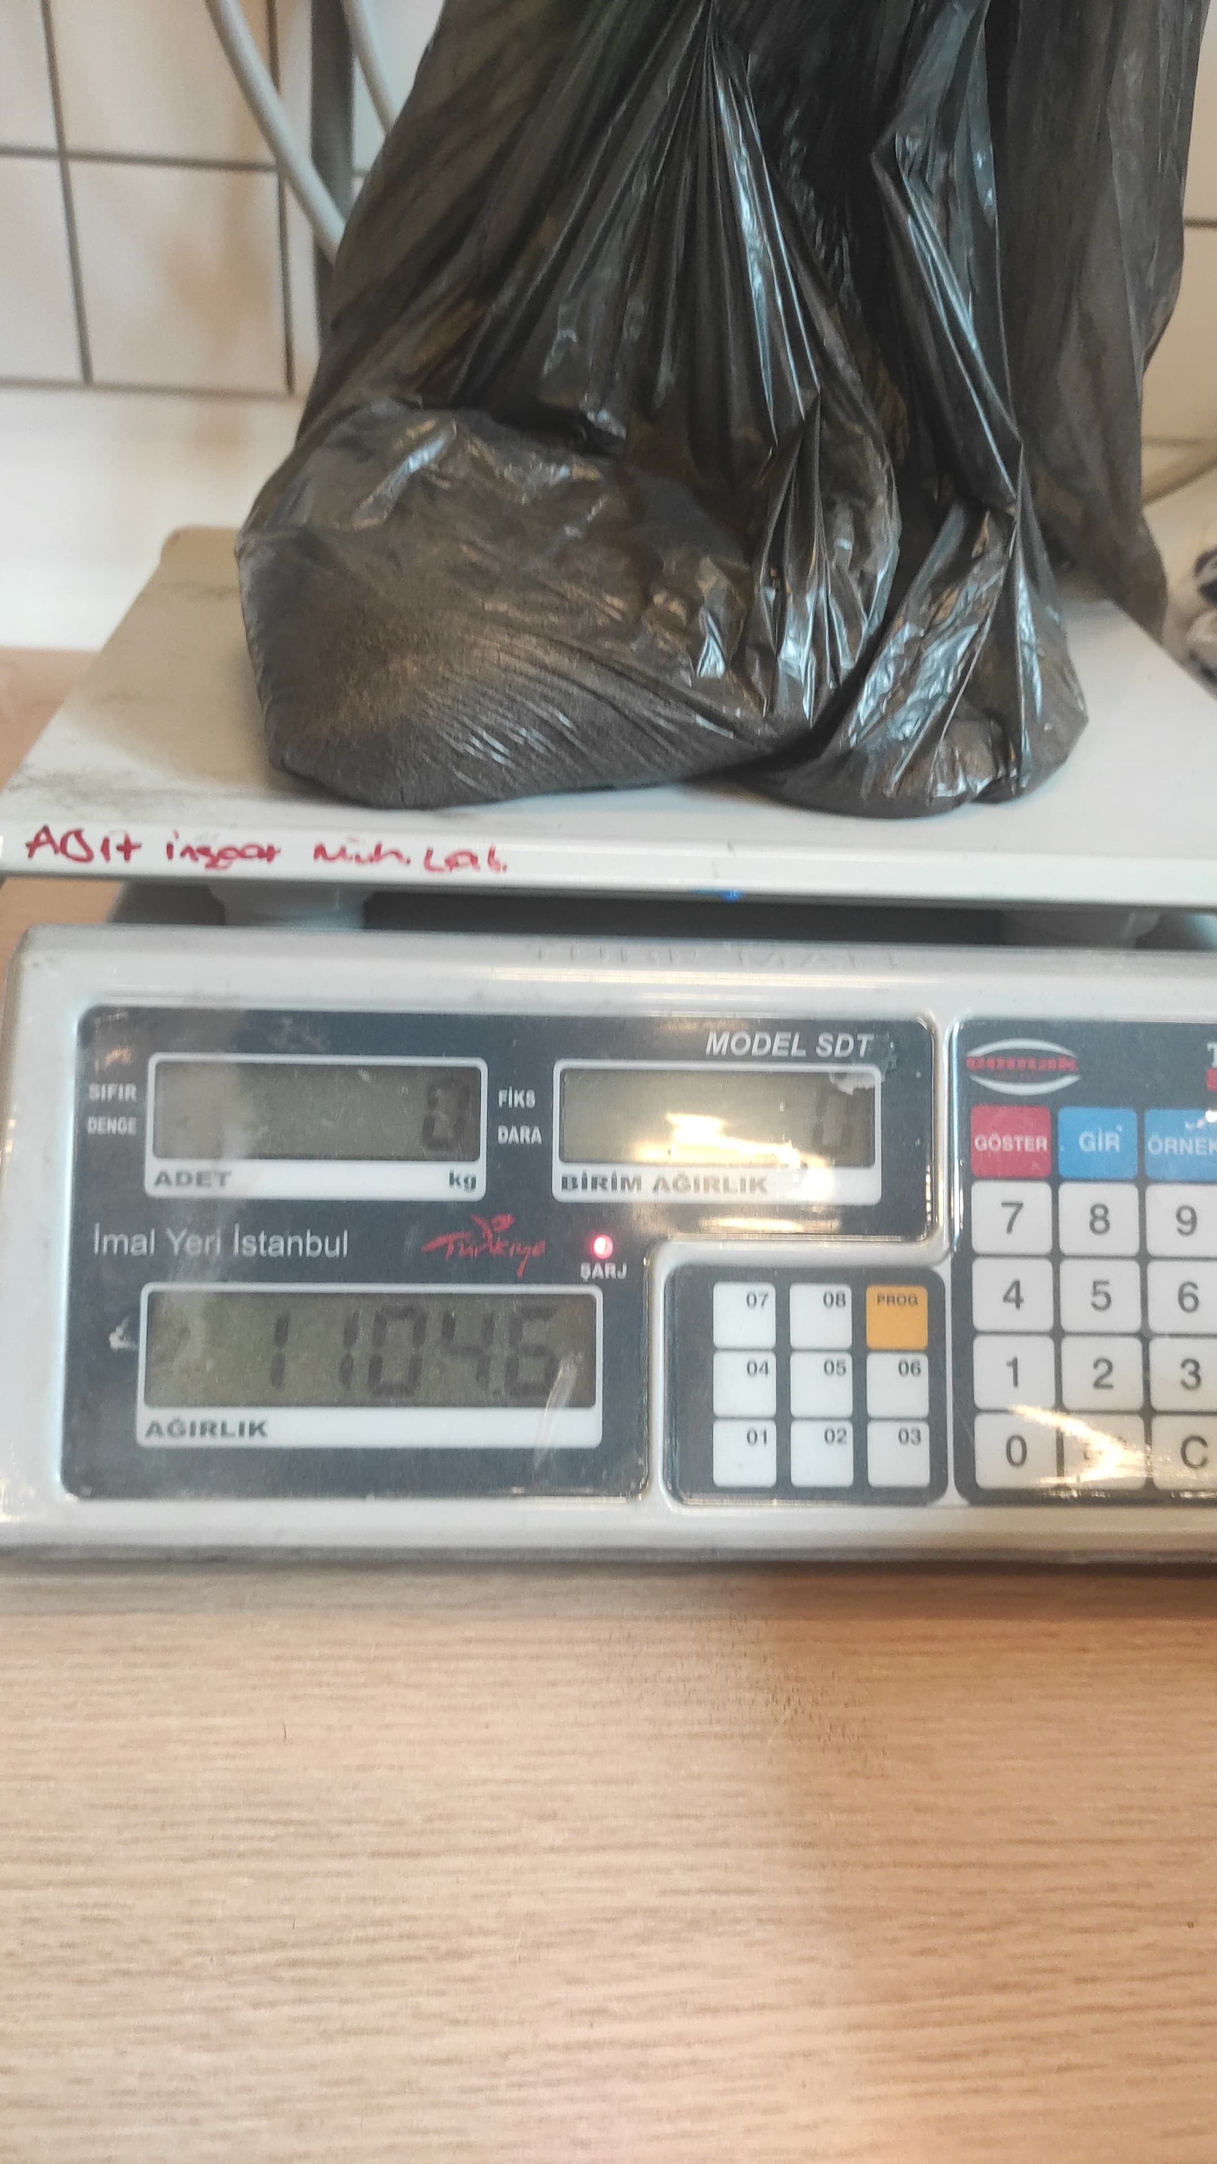

**4.1.3 Soil Imaging**

Once the samples are prepared, they are placed in a designated area for imaging. A controlled lighting setup ensures that the images are captured under consistent lighting conditions, reducing variability in the data caused by different light conditions. The soil sample is spread evenly on a flat surface and photographed using a high-resolution camera. For each soil sample, images are captured from multiple angles to account for surface texture variations. The camera setup is fixed on a tripod or automated imaging station to ensure repeatability.

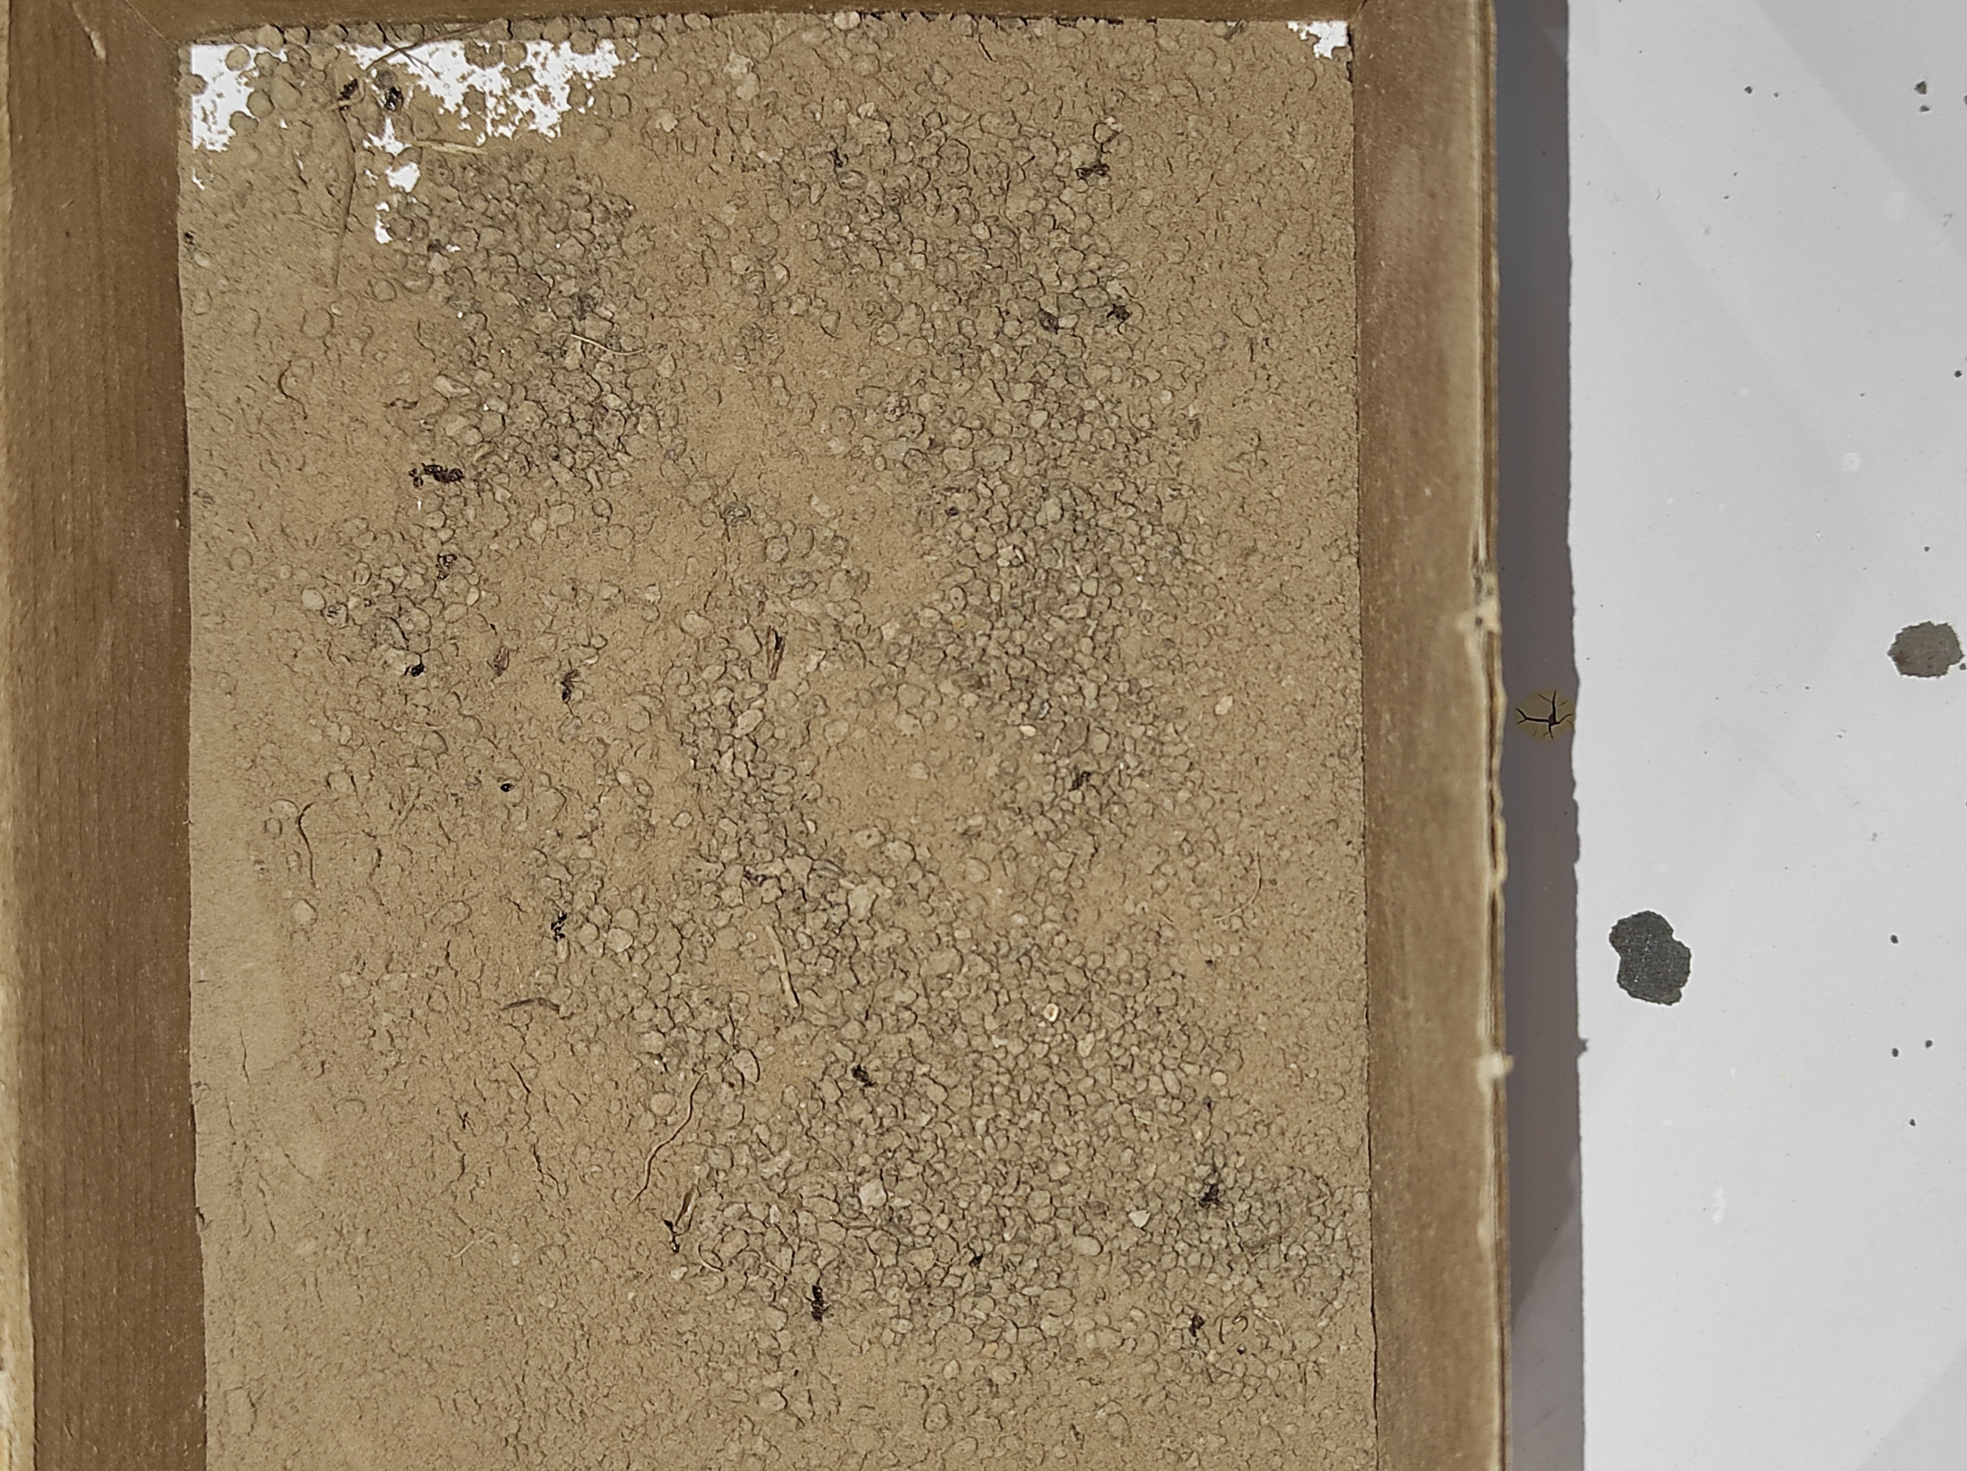These are the first try for soil imaging in black box at the laboratory.

**4.1.4 Soil Image Preprocessing**

Once the images are captured, several preprocessing steps are applied to optimize them for classification:

Image Cropping: Images are cropped solely on the area containing the soil sample, eliminating any irrelevant background or surrounding noise.

Color Normalization: Due to variations in lighting conditions, the colors of the soil may differ between images. Color normalization is performed to bring all images to a similar color balance.

**4.1.5 Integration with Machine Learning**

The laboratory processes—especially the soil preparation and imaging—feed into the machine learning pipeline:

Feature Extraction: The images are processed to extract important visual features such as texture, color patterns, and granularity.

Model Training: These features, combined with the labeled classes (A, B, C, D), are used to train machine learning models to classify the soil types accurately.

**4.1.6 Laboratory Equipment and Image Example**

The laboratory setup for soil preparation and imaging could include the following equipment: Oven: For drying soil samples.

Sieve Set: For classifying soil by size.

Digital Camera: For capturing high-resolution images of the soil samples.

Lighting Setup: To ensure consistent illumination image.

**4.2 Solution Approach**

The solution approach for this project involved systematic steps to classify soil texture based on clay and silt composition. These steps included dataset creation, preprocessing, augmentation, model selection, and evaluation:

**4.2.1 Dataset Preparation:**

* + **Collection:** Soil samples were collected from AGU dormitory gardens and processed in the civil engineering laboratory. The samples were divided into their total soil and clay-silt mixture components.
  + **Labeling:** Based on clay and silt content, samples were categorized into four classes (A: 0-25%, B: 26-50%, C: 51-75%, D: 76-100%).

**4.2.2 Preprocessing:**

* + Images were resized to maintain uniformity.
  + Pixel values were normalized to ensure consistency.
  + Each image was assigned a label corresponding to its class.

**4.2.3 Data Augmentation:**

* + To address the small dataset size, techniques such as rotation, flipping, and scaling were applied, increasing the dataset from 100 to 300 images.
  + An additional dataset of 100 images was collected and augmented, creating a final dataset of 600 images.

**4.2.4 Model Selection:**

* + A variety of models were tested, including CNN, EfficientNet, MobileNet, ResNet50, Random Forest, and VGG19.
  + U-Net architecture was selected for its strong performance in image segmentation and classification tasks.

**4.2.5 Evaluation Metrics:**

* + Confusion matrices were used to evaluate classification accuracy.
  + Metrics like precision, recall, and F1-score provided insights into model performance.
  1. **Model Results**

**4.3.1 Initial Dataset Performance:**

* + Models trained on the initial dataset of 300 images showed limited accuracy due to the small dataset size and class imbalances.
  + Random Forest and CNN architectures yielded better results than other models.

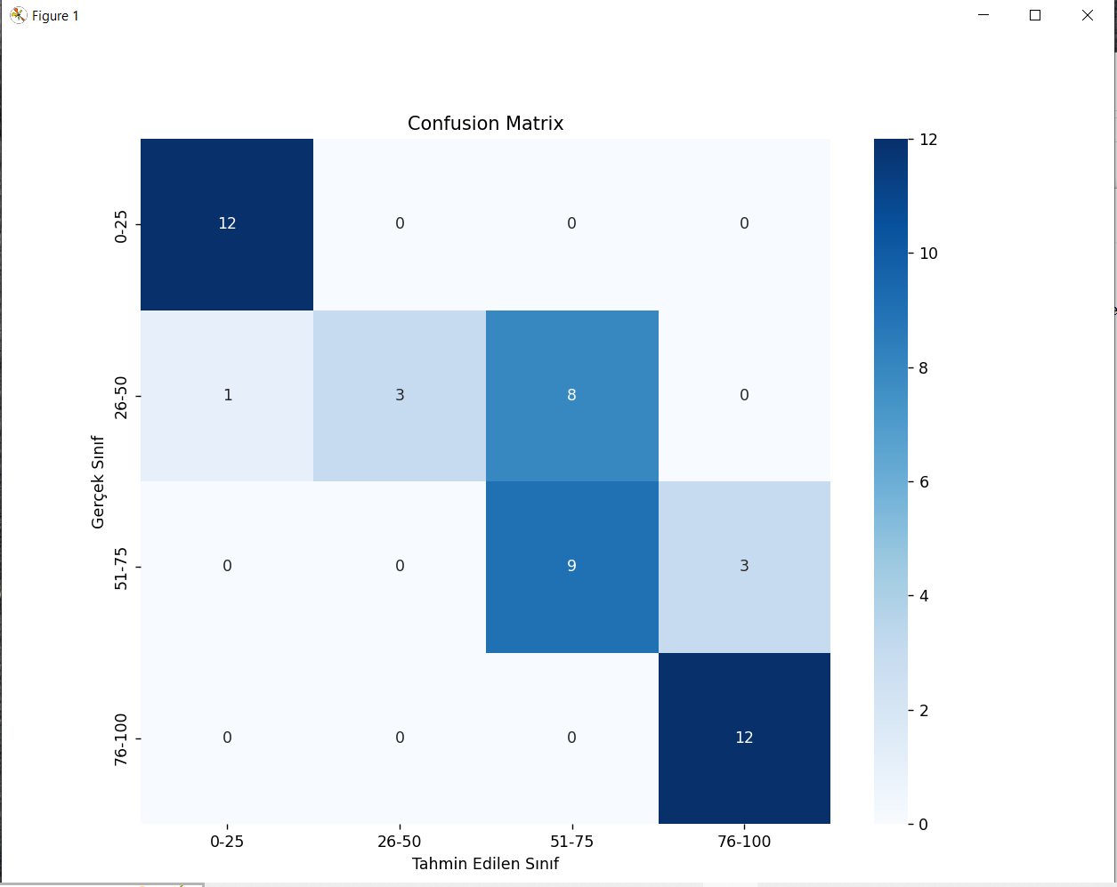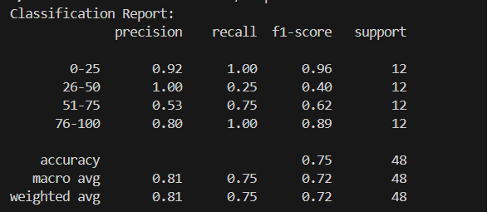**CNN 50epoch for 300 images:**

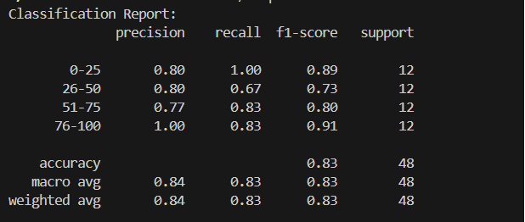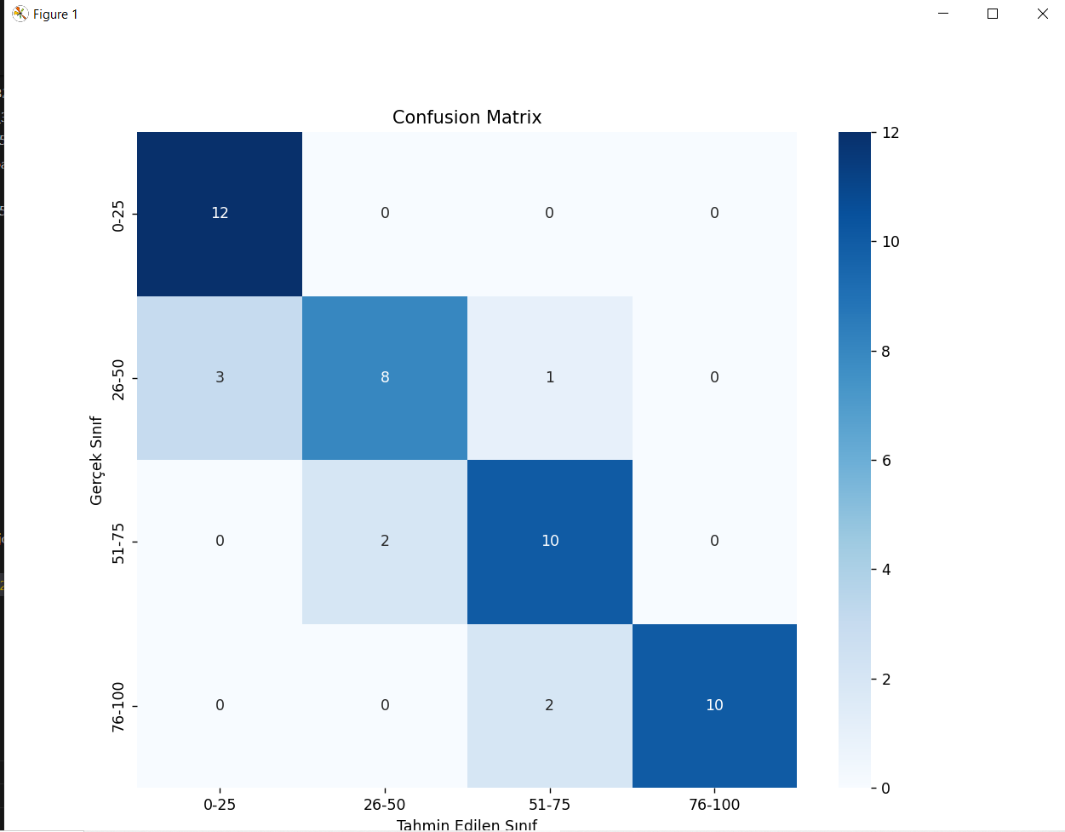**CNN 100epoch for 300 images:**

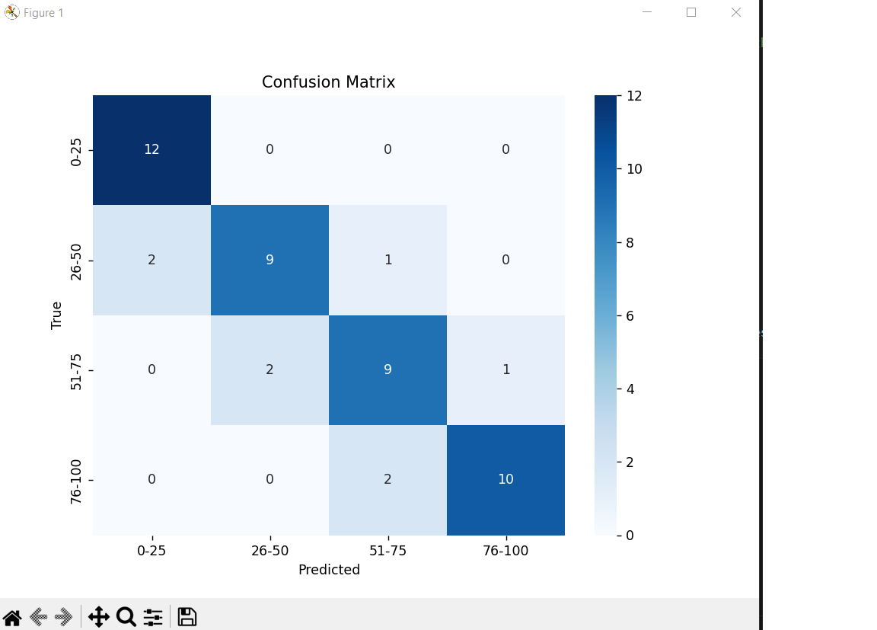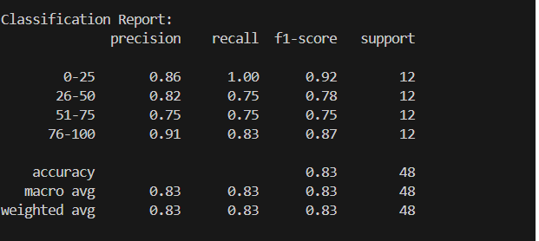**Random Forest 50 estimator for 300 images:**

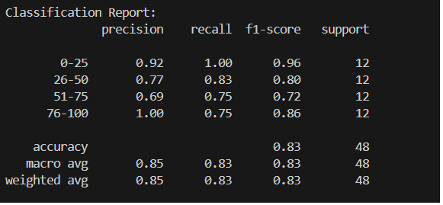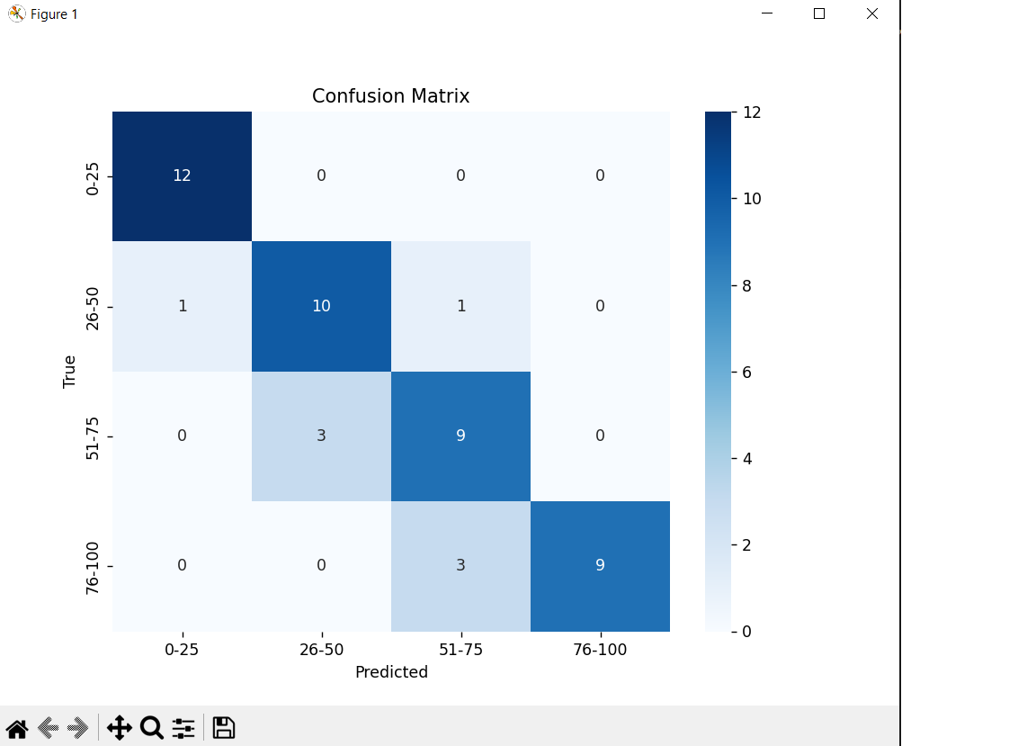**Random Forest 200 estimator for 300 images:**

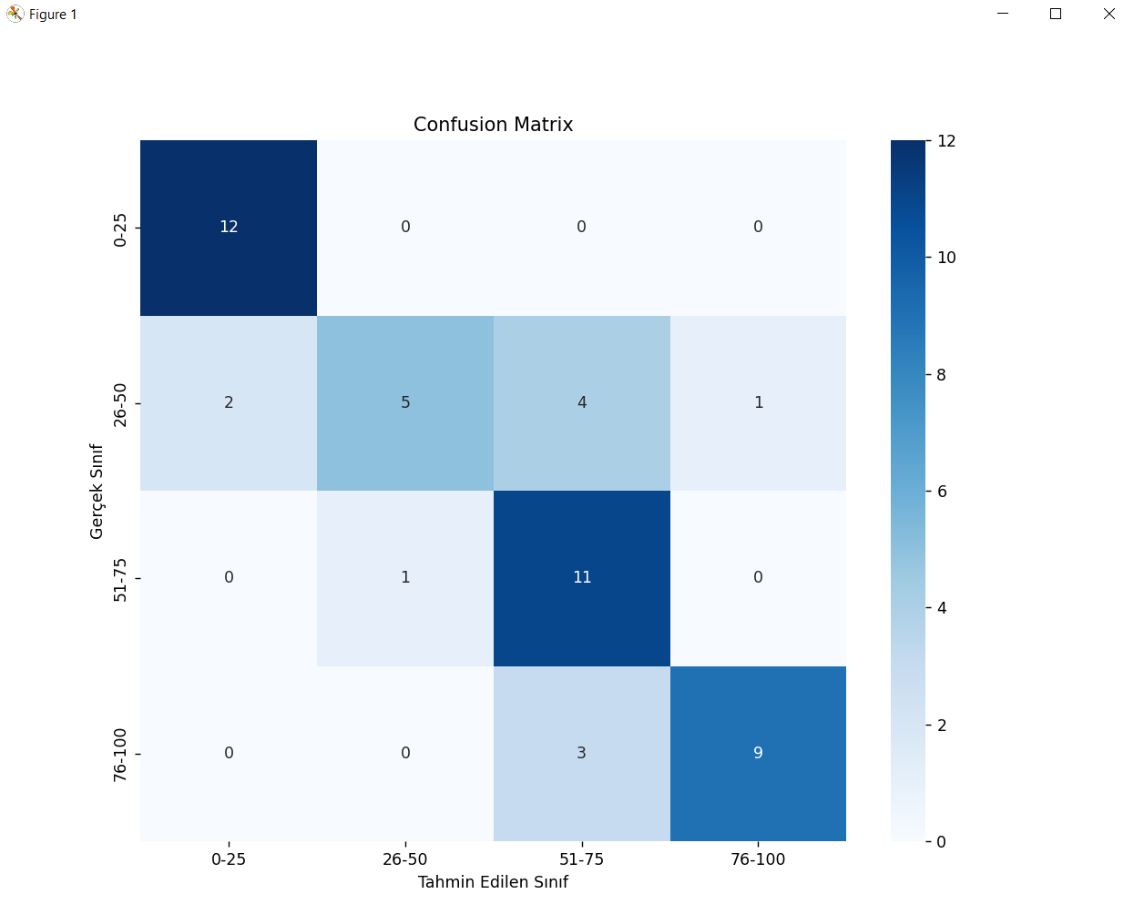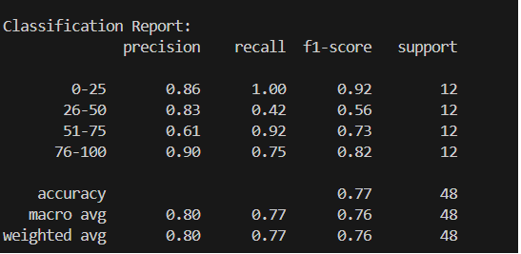**Mobilnet 50epoch for 300 images:**

**CNN 50epoch for 600 images:**

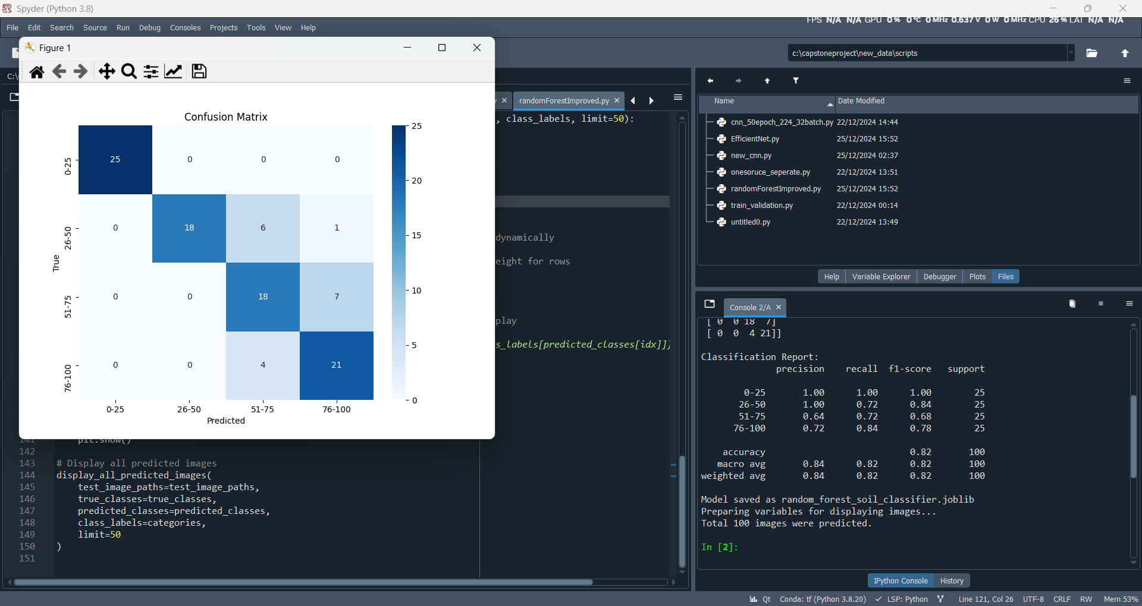**Random Forest 200 estimator for 600 images:**

**Mobilnet 50epoch for 600 images:**

1. **PERFORMANCE EVALUATIONS (3 pages at most)**

The performance evaluation of the soil classification system involved a comprehensive analysis of the trained models to assess their accuracy, robustness, and real-world applicability. The evaluation process was carried out using a dataset of 600 images, derived from two augmented datasets, with a 70-15-15 split into training, validation, and test sets.

**5.1 Evaluation Metrics:**

To measure the effectiveness of the models, the following metrics were employed:

1. **Accuracy:** The percentage of correctly classified images across all categories.
2. **Precision, Recall, and F1-Score:** Evaluated for each soil class (A, B, C, and D) to provide a detailed analysis of model performance in distinguishing among the four classes.
3. **Confusion Matrix:** Used to visualize the classification results, highlighting correct and incorrect predictions for each class.

**5.2 Model Performance**

Several machine learning and deep learning models were tested, including CNN, EfficientNet, MobileNet, ResNet50, Random Forest, and VGG19. Initial results on the first 300-image dataset revealed suboptimal accuracy, with significant misclassification due to the limited diversity and size of the dataset.

After expanding the dataset to 600 images through additional data collection and augmentation, the models showed improved performance. The results are summarized below:

**CNN:** Achieved a balanced performance with an accuracy of approximately 85%, effectively distinguishing classes A and D but showing some confusion classes B and C.

**MobileNet:** Model demonstrated similar performance like CNN, with accuracies around 82%. They excelled in capturing subtle texture differences in classes A and D but struggled slightly with extreme cases like classes B and C.

**ResNet50:** It performed low classification accuracy of 64% because of data size and its complex architecture.

**Random Forest:** Achieved a balanced performance with an accuracy of approximately 84%, effectively distinguishing classes A and D but showing some confusion classes B and C.

**5.3 Error Analysis**

A confusion matrix was generated for each model to identify specific challenges in classification. Misclassification patterns were most evident between classes A and D, likely due to their overlapping visual features in the combined clay-silt textures. Further investigation suggested that the lighting conditions and soil preparation inconsistencies during image capture contributed to these errors.

**5.4 Software and Hardware Technologies**

The development and evaluation of the soil classification system involved the use of various software and hardware technologies, tools, and environments:

**Software Tools**

* **Programming Languages:** Python (for machine learning and deep learning)
* **Libraries and Frameworks:**
  + TensorFlow and Keras: For building and training CNN models
  + scikit-learn: For Random Forest model and feature analysis
  + OpenCV: For preprocessing tasks like image resizing and augmentation
  + Matplotlib and Seaborn: For visualizing data and evaluation metrics
* **Data Augmentation Tools:** Integrated augmentation pipelines in TensorFlow and OpenCV
* **Visualization Tools:** Confusion matrices and metric plots using Matplotlib

**Hardware Technologies**

* **Computing Environment:**
  + GPU: NVIDIA RTX 3060 for training deep learning models efficiently
  + CPU: Intel Core i5-10300H for preprocessing and classical machine learning tasks
* **Storage:** SSD storage for high-speed data access during training
* **Image Capture:**
  + DSLR Camera: Used to capture high-resolution images of soil samples
  + Lighting Setup: Ensured consistent illumination during image capture to reduce noise
* **Laboratory Equipment:** For soil preparation and sample collection

**Development Environment**

* **Operating System:** Windows 10
* **Integrated Development Environment (IDE):** Visual Studio Code

1. **CONCLUSIONS (1 page at most)**

In conclusion, this project demonstrates the potential of leveraging computer vision and machine learning for efficient and accurate soil classification. By focusing on the combined clay and silt content to categorize soil into predefined classes, we have simplified the traditionally complex process of soil texture analysis. The development of a robust, augmented dataset and the application of advanced models such as CNNs, EfficientNet, and Random Forest have highlighted the effectiveness of integrating innovative techniques to overcome dataset limitations and variability in real-world conditions.

This targeted approach provides a scalable, cost-effective solution with significant implications for agriculture, environmental planning, and related fields. By addressing the limitations of traditional methods, our work lays the groundwork for future advancements in soil analysis and AI-driven applications in resource management, making it a valuable contribution to both scientific research and practical implementation.

1. **REFERENCES**

[1] R. K. Swetha, P. Bende, K. Singh, S. Gorthi, A. Biswas, B. Li, D. C. Weindorf, and S. Chakraborty, "Predicting soil texture from smartphone-captured digital images and an application," Geoderma, vol. 376, pp. 114562, 2020.

**[2]** P. A. de Oliveira Morais, D. M. de Souza, M. T. de Melo Carvalho, B. E. Madari, and A. E. de Oliveira, "Predicting soil texture using image analysis," Microchemical Journal, vol. 146, pp. 455–463, 2019.

**[3]** S. Inazumi, S. Intui, A. Jotisankasa, S. Chaiprakaikeow, and K. Kojima, "Artificial intelligence system for supporting soil classification," Results in Engineering, vol. 8, p. 100188, 2020.

1. **APPENDIX**

Turnitin report should stand here.